RESSAC
Case study: Multi-System level Modeling & Simulation (MS M&S)

Domain: System

Context and Purpose
The use case was originally proposed to support experimentation of the OPs at multi-system specification stage. Focus was on streamlining assurance by extensive use of model-based specifications (digital twin orientation), and on exploration of functional safety engineering by means of contract-based development. It was anchored to the µXAV drone example. (https://github.com/AdaCore/RESSAC_Use_Case).
It has evolved as a generic process-pattern that explores safety-driven streamlining of development assurance for any tier of decomposition:
- Multi-system -> system
- System -> subsystem
- Subsystem -> equipment
- equipment -> hardware-software co-design
- Software system -> software subsystem
- Hardware system -> hardware subsystem
The process-pattern is intended to fit coarse-grained recursive decomposition of behavioral complexity, when the interaction structure, i.e. the architecture, is exposed to safety assessment. The final fine-grained decompositions without architectural safety assessment are envisioned as development processes of compliance-translational nature, i.e. subject to item-type assurance rationale.
Following the genuine nature of the OPs, i.e. assurance properties of the product at development completion, the process-pattern has been looked for as the process-based part of the product’s safety-case argument.
On safety aspects the process pattern follows a top-down correct-by-construction approach supported by safety contracts. Since the pattern is structured as a systematic functional safety construction and verification process schema, comparison of the pattern with the current ARP4754-conformant processes may shed light on how to identify streamlining opportunities.
The generic view of the use case follows ideas previously promoted by IP217 and by the TIAM process pattern. It aims at being uniform on system, complex software and complex hardware. It also intends to rebalance assurance effort from item level to system level, when item engineering is of translational nature and reliably mechanized. As model-based system engineering (digital twins, virtual products, digital continuity) and model-based hardware/software engineering (HW synthesis tool, ACGs, control toolboxes, etc.) keep gaining momentum, it is likely to be ever more often the case in the future.

Following this streamlining orientation, tool trustworthiness substantiation will become even more critical, especially for the system engineering tools. Streamlining tool qualification and making it more balanced between system, software and hardware is perceived as a consequence of the assurance streamlining method proposed in this use case, was it to turn out to be fruitful.
As a methodological exercise, streamlining in the use case has been set at extreme level: only the activities related to safety-by-design and safety verification, incumbent to the development process, are defined. The use case is an attempt of “trimming the fat down to the bones”, i.e. an attempt of addressing only the bones of functional safety design and verification.
Development activities related to mission critical aspects are only sketched.

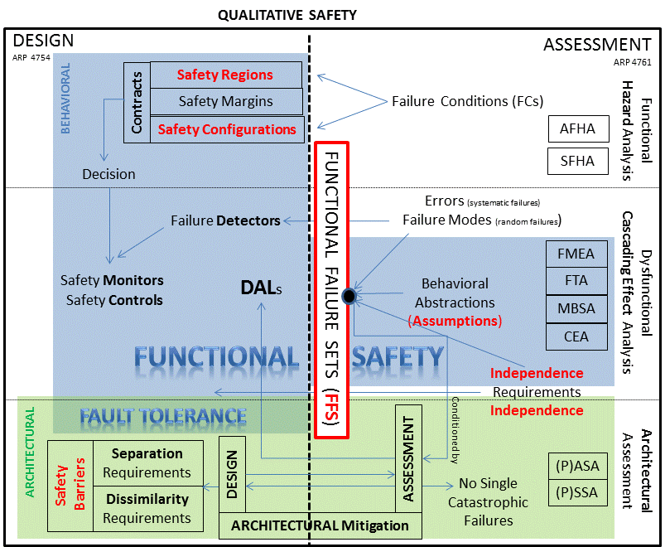
Figure 1: Functional Safety = DAL?
System functional safety concepts within the scope of the OPs and Criteria
The use case makes the relationship between architectural safety (architectural mitigation of failure conditions) and functional safety (software-based control to keep dynamics in the specified safety envelopes) more explicit by means of safety-contracts that define the safety regions. A geometric view of behavioral spaces is adopted that enables an approach to system verification coverage that goes beyond requirement coverage.
In the sequel, ‘behavioral safety’ and ‘functional safety’ are used as synonymous (blue area on figure 1), as opposed to architectural safety (green area). In figure 1 functional safety, advocated to be within the scope of the OPs, is prolonged to the part outside of the scope of the OPs because FFSs are pivotal behavioral abstractions whose validity is critical and should be a major concern of the people in charge of the abstracted design.
Split of safety assurance in two processes (development assurance and safety assessment), with two industrial standards (ARP 4754 and ARP 4761), could lead to overestimate the role of safety assessment in the development assurance rationale: “safety is addressed by safety assessment”, or “the DAL is the development side of safety assurance”.
The process pattern proposed in this use case addresses the development part of safety engineering: design of architectural mitigation and design of functional safety.
Design assurance, following a safety-case-like argument structure and limited to these two design domains, is proposed as the safe residual (i.e “the bones”, the minimal kernel) of any sensible streamlining attempt.
Two sorts of models are exchanged in the use case:
- ‘A-models’, standing for ‘Architectural models’. A-models are static (annotated graphs). Architecture modeling plays a major role in design of architectural mitigation. A-models must be complete at any time. Beyond architecture engineering, they are the backbones that help development teams to communicate, synchronize, and inform project management,
- ‘B-models’, standing for ‘Behavioral models’. B-models are dynamic (first principles models). They may be partial. Scoping of behavioral modelling is based on cost/benefit ratio, so that behavioral specification always features some document-model mix.
It is assumed that a text and model tagging mechanism ensures that:
- the specifying traits are stated and identified either in the model or in the text, never in both (complementarity),
- in both text and model the specifying traits are distinguished from explanatory and auxiliary specification material (isolation).

B-models share some architectural information with A-models. A-models are the reference definition of the functional architecture, of the organic architecture, and of the mapping of the former on the latter. B-models must comply with A-models on the shared architectural information, which comprises:
- The functional architecture (function names, interfaces, data flows, hierarchical decomposition),
- The logical architecture (physical or cyber resources whose technological nature and installation aspects may be left undefined),
- The mapping of functions on logical resources.
“Functional specification” is interpreted in the use case as definition of the specified behavior mapped on the logical resources whose engineering is delegated at lower level (system, sub-system, equipment, software item, hardware item or physical item).
Intellectual Property protection is an issue in model-exchange between two different companies or within the same company.
The use case assumes that IP-protection may be applied to B-models by means of encryption of the physical equations and of the programs.
On the contrary it assumes that no information hiding is applied to the A-models. Transparency of the A-models is deemed required by architectural safety verification:
- Generic interpretation: the level k integrator must know the internal structure of the entities composing this level to design the separation means and the functional mappings at this level.
- Instantiated interpretation: the fault tolerance mechanisms of the flight control loop cannot be designed if the architectures of the electrical and hydraulic systems are not transparent.
Local architectural opacities would prevent comprehensive dependency analysis, with possibly overlooked dependencies that would invalidate independence hypotheses between organic failure modes, or between functions.
Information hiding on the intentional definition of behaviors exacerbates safety responsibility issues. For any stakeholder (OEM or tiers), responsibility of hidden parts seems difficult to conceive. The specifications enriched by the suppliers (resp. by level (k+1) actors) are more akin to a virtual implementation than to a specification endorsed by the OEM (resp. by the level k integrator). Hence the denomination “tier1-model” for any model mixing level-k and level-(k+1) models (generic view), or mixing OEM and supplier models (instantiated view).

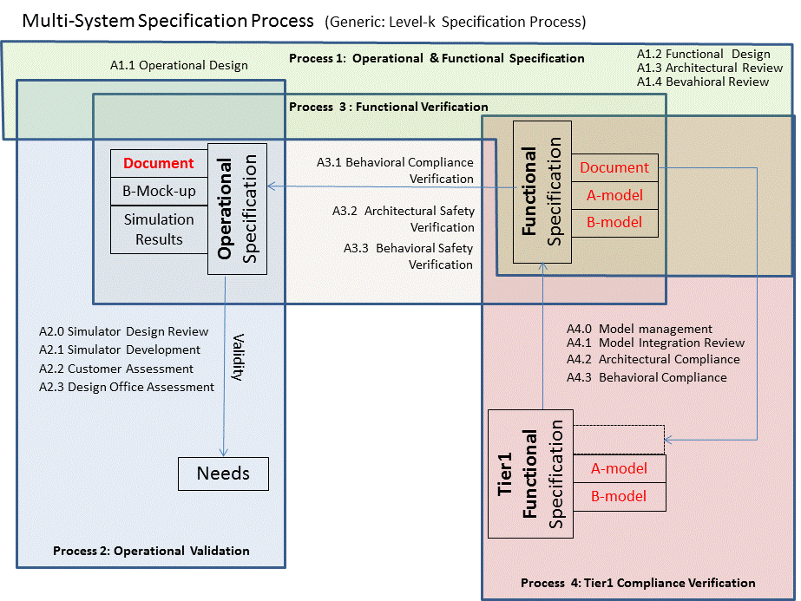

Figure 2: Outline of the Process Pattern
Four processes: Authoring, Context Validation, k-Compliance, (k+1)-to-k-Compliance.

Expected Benefits
- Process aspects: a recursive development & verification pattern limited to the safety-essentials (i.e most streamlined because contains only what is needed to prove safety).
- Product aspects (instantiated interpretation):
  - Quality of customers’ needs capture by means of operational rapid prototyping and immersive simulation,
  - Feasibility risk reduction by coupling operational specification with functional design and dimensioning,
  - Rework reduction by:
    - AV-level virtual integration of the OEM’s system specifications (top-down flow)
    - AV-level virtual integration of the suppliers’ system specifications (bottom-up flow)

Process description
Process description mixes the instantiated and the generic interpretations of the use case:
- The operational part (A1.1 and process 2) is presented with the instantiated interpretation: drone’s multi-system, operating conditions, OEM, system design delegated to suppliers, etc. The generic view (TIAM-like process pattern) is sketched in a separate additional paragraph,
- The functional part (the remaining part of process 1, processes 3 and 4) is presented with the generic interpretation. Some local hints to the instantiated interpretation are added when thought helpful on abstract or technical aspects.

In the instantiated setting, the process features iterative virtual prototyping of systems at air-vehicle level (multi-system), and system level. It features architectural and behavioral model exchange between the OEM and the system suppliers.
Integration of system specification models is motivated by identification of the safety risks related to dynamical interactions between systems. It is done since the early stages of development, e.g. conceptual design and requirement capture, and synchronized with implementation development.

The instantiated view of figure 2 is:
- Co-development of the operational and functional specification at air-vehicle level (process 1),
- Validation of the drone’s operational specification (process 2),
- Integration verification of OEM’s functional specification (process 3),
- Integration verification of the suppliers’ functional specifications (process 4),

  - Life cycle overview
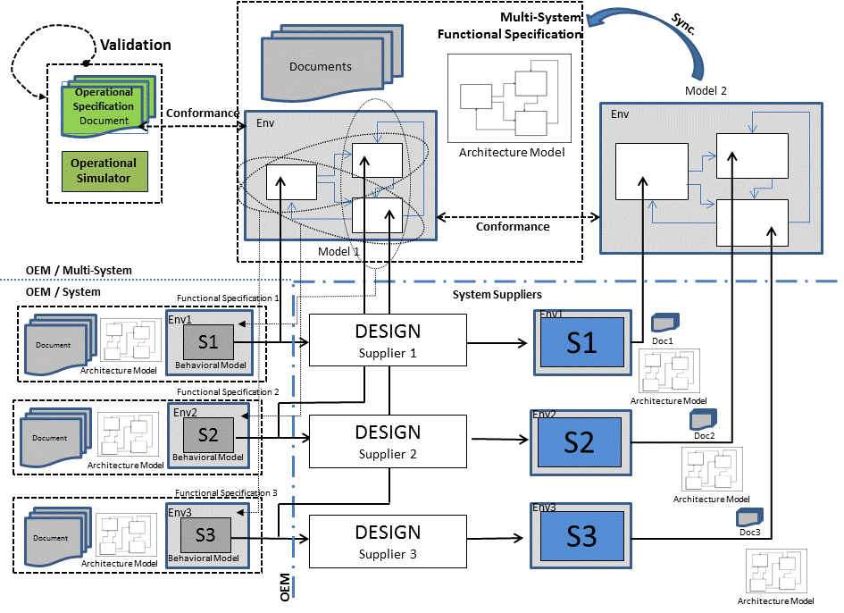
Figure 1: Exchange of specification artifacts between the multi-system and the system levels (resp. Lk<->L(k+1) specification artifacts exchange).
As a minimum the OEM models the most safety-critical parts of the systems, for instance when their dynamics are tightly coupled and condition occurrence of catastrophic failure conditions. Modeling may also be required when physical dimensioning or control design is difficult (early risk identification and mitigation policy). The OEM simulates the virtual integration of his system functional specifications on dimensioning scenarios.

The first model that integrates system specifications is named model 1. Model 1 is co-engineered with the functional specification document and with the architectural model. On the OEM side, system specification is uniformly managed at multi-system and system levels. In both cases it is made of three artifacts: document, A-model, B-model.

Contrary to the functional case, the operational specification consists of a document only. It is supplemented by rapid prototyping and immersive simulation, but these artifacts are only auxiliary validation means deprived of specification role.

Model 1 has two purposes:
- Feasibility analysis of dynamics’ control, design of the architectural and behavioral specifications that meet the ergonomic and performance objectives assessed by the customers in the immersive simulation center. This OEM specification spans over several systems,
- Detailed behavioral specification, compared to textual specification, to reduce specification errors generating rework late in the development,

The second part of the use case is devoted to OEM multi-system virtual integration of the supplier-provided system specifications. Model 2, a model-mix of OEM-provided and supplier-provided models, is a tier1 model. It supports behavioral verification of the suppliers’ specifications interacting through the OEM-specified multi-system architecture.

Similarly, a multi-system architectural model integrates the suppliers’ system architectural models. It is used for the architectural aspects of multi-system functional safety analysis (design side, green part of figure 1).

The OEM delivers to any system supplier participating to the model-based co-engineering process:
- his system functional specification document,
- The OEM system architectural model (partial model akin to architectural constraints),
- The OEM system behavioral model (possibly partial, with precise or approximate dynamics, depending on safety criticality and OEM’s expertise),
- A simulation environment to run the system behavioral model (OEM’s and supplier’s) in a context representative of air-vehicle missions, of environmental conditions, and of interaction with the other systems (represented as a thin rectangle strip surrounding the B-models on figure 3),
The suppliers send back to the OEM a similar three-artifact specification package:
- A document presenting the key aspects of his design and the discrepancies or technical issues of his bidding proposal. The system specification remains that authored by the OEM, possibly incorporating over time the negotiated additional specification elements provided by the supplier.
- A supplemented A-model,
- A new B-model implementing the full detailed specification, in a way compliant with the model-exchange guidelines
The OEM integrates the A- models and the B-models provided by his suppliers in his multi-system A- model and in his tier1-multi-system B-model (abbreviated model 2).
Model 2 is used to check that:
- the enriched system specifications, embedding the ‘true’ sensor, controller and actuator performances, interact appropriately on dimensioning scenarios (safety and mission performance),
- the global behavior remains compliant with the validated operational scenarios,

The specifications’ lifecycle and exchange management is complex (internal and external exchanges). It requires a dedicated process activity (A4.0).

  - Planning process

Typically the first process/activity described should be the planning process. It produces a set of plans and possibly applicable standards and guidelines. The plans describe the life cycle, activities, I/O, methods, environments, responsibilities, error sources and classes.

In the scope of this use case, the planning process is limited to the present document.

  - Process 1: Operational and Functional Specification

This process is defined by the following activities:
- Operational design (A1.1)
- Functional design (A1.2)
- Architectural review (A1.3)
- Behavioral review (A1.4)

A1.1 Activity: Operational Design
Inputs:
- Market survey material (I1) (from out of scope processes),
- Conceptual design documents (I2) (from out of scope processes),

Outputs:
- Operational specification document (O1) (to process 2 and 3)

Method and environment:
- Scenario-based textual description,
- Check lists and systematic structuring of groups of scenarios to cope with combinatorial explosion while ensuring best effort ‘completeness’,
- Use of design drivers derived from customer feedback

Responsibility:
- OEM/Air-vehicle conceptual designers,
- OEM/System designers,

Description:
Operation-oriented designers describe how to operate the drone (external view). This preliminary design meets the expectancies formulated in (I1) and the constraints in (I2). The behavior (flight dynamics, ground operations and man-machine interactions) is described by means of structured groups of scenarios (O1).
The performance objectives and the architectural constraints formulated by the customer are recorded as additional elements in the operational specification document (O1).

Operational design addresses:
- Operational concepts in normal conditions
  - Fleet level capabilities (a)
  - Mission performances (b)
  - Ergonomics of MMI (c)
  - Suitability of operating procedures (d)
  - Definition of normal conditions (e)
    - Mission profiles
    - Energy resources
    - Weather conditions (wind, temperature, icing)
    - EM and RF environment
- Abnormal conditions
  - Tolerated abnormal conditions (robustness, amber zones)
  - Non-tolerated abnormal conditions (failure conditions, red zones)
  - Failure modes if user-observable
- Architectural constraints
  - Customer-specified pieces of equipment, if any

Errors sources and classes

Errors | Means of detection
Biased conception of “user-friendliness” (E1.1a) | A2.2 Customer Assessment
Product inadequate to market (E1.1b) | A2.2 Customer Assessment
Dimensioning inadequate to customer needs (E1.1c) | A2.3 Design Office Assessment
Overselling of marketing (E1.1d) | A2.3 Design Office Assessment
Non closure of “abnormal conditions” and “foreseeable operating conditions” (E1.1e) | A2.3 Design Office Assessment

Generic interpretation
Operational design or operational specification may sound a bit weird at sub-system level, and even more so at item level. In these cases, “operational” would preferably be replaced by ‘Context’, ‘Environment’, ‘Needs’, or ‘Client’.

Specifying with appropriate precision the environment behavior that interacts with the entity of interest is important, in particular when integrating COTS. Synthesis of system environment models that are ‘multi-system-aware’ is represented in figure 3 by the ellipses and arrows from multi-system modelling down to system modelling. This environment model synthesis approach is generic, it uses the level k model to generate the level (k+1) environment models.

Specification, in a scenario-based manner, of the way the environment stimulates the entity of interest and of the way it responds and influences the environment, is the purpose of A1.1 “Operational Design” in the generic interpretation.

A1.2 Activity: Functional Design

Inputs:
- Multi-system operational specification (I1) (from A1.1)
- Conceptual design dossier (I2) (from out of scope processes),
- Applicable certification documents (I3) (from the certification liaison process),
- Preliminary Air-vehicle Safety Assessment dossier (I4) (from the safety assessment process)
- Functional specification package of the systems to be integrated (I5) (from A4.0)
- Air-vehicle Functional Hazard Analysis (AFHA) (I6) (from the safety assessment process)

Outputs:
- Multi-system functional specification document (O1) (to A4.0)
- Multi-system architectural model (O2) (to A4.0)
- Multi-system behavioral model, alias model 1 of figure 3 (O3) (to A4.0)
- Multi-system input scenarios (O4) (to A4.0)

Method and environment:
- The activity addresses the system couplings, i.e the AV functions mapped on more than one system, that are needed to meet the mission requirements and to mitigate the failure conditions (I3, I6, I4),
- Functional design addresses definition of the qualitative safety objectives at air-vehicle level (AV’s safety region), definition of the needed functional interactions between the systems (mission needs, safety needs), definition of the architectural resources to support these interactions, and identification of the control loops spanning over more than one system.
- A-models: SysML tool, databases, spreadsheets, etc.
- B-models: Simulink, Modelica-based tool, etc.

Responsibility:
- OEM/multi-system architects
- OEM/air-vehicle functional safety experts
- OEM/pilots, drone operators

Description:
- Definition of the AV’s safety zone
  - The natural language definitions of the Failure Conditions of (I6) are made unambiguous by modelling them as a predicate over some air-vehicle and/or environment variables. These predicates define the ‘safety escape’ boundaries, i.e. entry in some catastrophic/hazardous states (red zones). There is one AV red zone defined per hazardous or catastrophic FC of the AFHA.
  - The geometry of the red zones is analyzed. An AV kinematic envelope sufficient to complete all the mission profiles without intersecting the red zone is defined over the same variables.
  - Safety margins may be defined when appropriate, as amber zones lying between the green and red ones. They are traversed when control does not compensate enough for perturbations, so that AV’s dynamics escapes from the green zone toward some part of the red boundary.
Conjoining the green and amber zones for all the hazardous and catastrophic FCs constitutes the air-vehicle safety zone. This safety zone constitutes the conclusion part of the AV’s safety contract. It is documented in (O1) and implemented in model 1 (O3).

- Predefinition of the systems’ safety zones
Keeping AV’s dynamics inside the AV green zone is “decomposed” as an interaction of system dynamics each controlled to stay within its own green zone. Design ensures that AV’s dynamics will stay in its green zone provided all the systems’ dynamics stay in theirs. Systems’ amber zones are designed so that the AV stays in its green or amber zone provided that every system stays in its green zone or in its amber zone.
This multi-system safety control design is documented in (O1).
The system zones defined in this activity are predefinitions. They are tuned at system level when SFHA red zones are addressed. Zone definitions are implemented into executable contracts. Top-down contract-based safety zone definition supports incremental certification when contract compositionality is verifiable.

- Architectural design
The pieces of equipment are defined (energy sources, physical devices, sensors, actuators, and controllers) so that the mission performance requirements are met (I1, I2).
Their failure modes are identified and documented in (O1).
Fault-tolerant architectural patterns are selected, connected and configured to meet (I3) and comply with (I4).
The AV functions are mapped on the resources so that the fault tolerance objectives are met (I3).
The architecture and the functional mapping are defined in the A-model (O2).

- Safety controls
Control laws are defined at system level and must comply with (O1).
When (I5) is available, the B-models are integrated in model 1 (O3).
Model 1 prototypes all the functional safety controls specified to prevent escape in the hazardous and catastrophic AV red zones.

- Perturbation compensation
(I1) is analyzed to develop the input scenarios that stimulate model 1 (O4).
The failure scenarios triggered by the failure modes listed in (O2) but not referenced in (I1) are designed and added to (O4).
The natural language definitions of the normal and tolerated-abnormal conditions are modeled as predicates over environment variables. They constitute the green and amber zones of the environment’s dynamical space. This precondition logic is added as premise to the conclusion part of the AV’s safety contract. The implication constitutes the AV’s safety contract. Its implementation as executable assertion in model 1 is the reference definition. A natural language formulation is introduced in (O1) to help reading the executable formulation.
Perturbation compensation laws are defined at system level.

- Mission services
Mission aspects supplement (O1) when the involved functions are mapped on more than one system. Mission aspects do not modify (O2), unless mission specific resources are added.
Model 1 integrates the mission services that are prototyped at system level.
All mission performance aspects that condition DAL A and DAL B safety control are prototyped in model 1.
The multi-system aspects of mission services that are not prototyped in model 1 are documented in (O1).

Errors sources and classes

Errors | Means of detection
Functional safety design errors
Wrong definition of the green zones (E1.2a) | A3.3 Behavioral Safety Verification
Wrong interaction of control laws in normal conditions (E1.2b) | A3.3 Behavioral Safety Verification
Wrong compensation of perturbations (E1.2c) | A3.3 Behavioral Safety Verification
Functional design errors
Non-compliance of the functional behavior with the operational scenarios (E1.2d) | A3.1 Behavioral Compliance
Incompatibility of the performance objectives with the components envisioned by procurement (E1.2e) | A1.3 Architectural Review
Inconsistency between the assumptions made by system designers and that made by conceptual designers (E1.2f) | A1.3 Architectural Review  A2.3 Design Office Review
Physical modelling errors
Safety-sensitive physical phenomena not represented in the environment models (E1.2g) | A1.3 Architectural Review  A1.4 Behavioral Review
Behavioral simulation errors
Time-resolution error: Shannon-like issues wt. to high dynamics (E1.2h) | A1.4 Behavioral Review
Event-handling error: overlooked physical events (E1.2i) | A1.4 Behavioral Review
Precision error: unstable simulation results (E1.2j) | A1.4 Behavioral Review

A1.3 Activity: Architectural Review

Inputs:
- Multi-system functional specification document (I1) (A1.2.O1)
- Multi-system A-model (I2) (A1.2.O2)
- Model 1 (I3) (A1.2.O3)
- PASA dossier (I4)
- Procurement dossier (I5)
- Conceptual design dossier (I6)

Outputs:
- Architectural review report (O1) (to A1.2, conceptual design, procurement and safety assessment)

Method and environment:
- Architecture modeler (e.g SysML tool – static structural modeling with viewer)
- Focus on system interconnections
- The purpose of the review is to detect architectural inconsistencies between the three artifacts, or with the architectural constraints imposed by external stakeholders. A1.3 is a sanity check before A3.2.

Responsibility: OEM/air-vehicle conceptual designer, OEM/multi-system architect

Description:
Two verifications are performed:
- First, (I2) is reviewed to ensure that:
  - The architectural design of A1.2 has been accurately modelled,
  - (I2) complies with the external sources of information it depends on:
    - Clearance of procurement on the selected components (I5)
    - Clearance of design office on the selected components and their attributes (packaging, dimensioning, performances, environmental conditions – E1.2f) (I6)
    - Compliance with the requirements from safety assessment (separation and dissimilarity) (I4)
- Second, after (I2) is granted the role of reference by completion of the first part of this activity (recorded in (O1)), (I1) and (I3) are reviewed against (I2) for architectural consistency of the three artifacts.
  - Document (I1) is reviewed on all aspects regarding architecture. In case of discrepancy alignment with (I2) is required, recorded in O1 and done by A1.2,
  - Model 1’s functional and organic architectural traits are reviewed. They must be identical to their (I2) counterpart. Discrepancies are recorded in (O1), alignment with (I2) is done by A1.2,
  - In case (I4) contains a MBSA model, the architectural part that reflects (I2) must be identical to (I2). Any discrepancy is recorded in (O1). Alignment of (I4) with (I2) is required and done by the safety assessment process.

Errors sources and classes

Errors | Means of detection
Incomplete misalignment detection: document vs A-model (E1.3a) | none
Incomplete misalignment detection: B-model vs A-model (E1.3b) | Trustworthy mechanized verification (applicant toolchain dependent)
Inconsistent models of the multi-system architecture (design and safety assessment) (E1.3c) | Trustworthy mechanized verification (applicant toolchain dependent)

A1.4 Activity: Behavioral Review

Inputs:
- Multi-system operational specification (I1) (A1.1.O1)
- Multi-system A-model (I2) (A1.2.O2)
- Multi-system B-model alias model 1 (I3) (A1.2.O3)
- OEM’s behavioral modeling standard (I4)

Outputs:
- Behavioral review report (O1) (to A1.2)

Method and environment:
- The verified artefact is model 1.
- The verification objective is to perform all verifications that are not done by simulation. They ensure that (I3) is consistent (I2) on the physical parameters. They ensure that numerical solving of the physical equations is sound.

Responsibility: OEM/system modelers, numerical simulation expert

Description:
The verification proceeds in two stages:
- Objective 1: The physical parts of model 1 contain the right equations wt. the physical devices of (I2) and the environment,
- Objective 2: a correct solution wt. the verified equations is computed by the numerical solver

The review is conformant to (I4) and focuses on:
- Inter-system causality, dynamic regimes, singularities, heterogeneity of time scales and energy scales,
- Configuration of the global numerical solver
- Concurrency aspects (e.g. multi-threading for time-efficient simulation) , if any

Physical modelling
- Modelling of the environmental conditions as defined by (I1), in particular the abnormal conditions are reviewed in (I3). Modelling fidelity of these conditions is substantiated in (O1).
- Modelling of the failure modes of (I1) is reviewed; fidelity is substantiated in (O1).
- The physical devices of the architecture (I2) are reviewed; fidelity is substantiated in (O1).
Solver configuration
- The check list of (I4) is applied by a numerical integration expert
- The solver configuration is recorded in (O1)
- The anticipated physical events to be numerically isolated are listed in (O1)
- Accuracy of simulation is substantiated in (O1)
Parallel simulation
- Transparency of concurrency on simulation accuracy is substantiated in (O1).
- The configuration of the parallel speed-up options is recorded.

Errors sources and classes

Errors | Means of detection
Omissions. | None. No verification of verification.

1.4 Process 2: Operational Validation
The activities of process 2 are:
- Simulator design review (A2.0)
- Simulator development (A2.1)
- Customer assessment (A2.2)
- Design office assessment (A2.3)

A2.0 Simulator Design Review

Inputs:
- Multi-system operational specification (I1) (from A1.1)
- Simulator design proposal (from the serious game development team)

Outputs:
- Operational simulator design dossier (O1) (to A4.1)

Method and environment:
- Review of the mock-up fidelity objectives
- Review of the available modelling libraries, and of the mapping of needs on resources,
- Technical meeting

Responsibility:
- OEM/conceptual design technical lead
- OEM/serious gaming technical lead

Description:
- Selection of the environment models needed by (I1) to ensure appropriate fidelity, parameterization of the external perturbations (abnormal conditions). Record in (O1).
- Selection of the AV’s 4D rendering
- Analysis of the scenarios defined in (I1): selection of the immersive resources. Record in (O1).
- Assessment of validity of validity assessment. Record in (O1).

Errors sources and classes

Errors | Means of detection
Biased rendering of the environment | A2.2 Customer Assessment  A2.3 Design Office Assessment
Biased rendering of MMI and ergonomics | A2.3 Design Office Assessment
Biased rendering of physical dynamics and controllability | A2.3 Design Office Assessment

A2.1 Simulator Development

Inputs:
- Multi-system operational specification (I1) (A1.1.O1)
- Operational simulator design dossier (I2) (A2.1.O1)

Outputs:
- Operational simulator (O1) (to A2.2 and A2.3)

Method and environment:
- Unity™ (as an example)
- VR helmet
- PC with GPU
- Etc.

Responsibility: OEM/serious gaming team, immersive reality center

Description:
- Rapid agent-based modelling
- Scripting of the scenarios defined in (I1)
- Run of the scenarios and assessment against (I1)
- Iteration of modelling & run until compliance with (I1) and (I2) is reached.

Errors sources and classes

Errors | Means of detection
Non-compliance with (I1 or I2) | A2.2 and A2.3

A2.2 Activity: Customer Assessment

Inputs:
- Multi-system operational specification (I1) (A1.1.O1)
- Operational simulator (I2) (A2.1.O1)
- Validation plan (I3) (from A2.3)

Outputs:
- Validation report (O1) (to A2.0, A2.1, A1.2)
- Validated and rejected simulation results (O2) (to A3.1)
- Validation plan (O3) (to A2.0, A2.1, A1.2)

Method and environment:
- Immersive reality center
- (I1) is the validated artifact
- (I2) is an illustrator that helps challenging (I1) and getting feedback from customers
- In case of customer dissatisfaction, (I1) is modified, the A2.0 -> A2.1 -> A2.2 loop is reentered

Responsibility:
- OEM/marketing lead
- OEM/conceptual design lead
- OEM/operational experts
- Customer representatives

Description:
- Validation of (I1) follows the structure of (I1), i.e. the structured list of 4 groups of scenarios:
  - nominal conditions, sampling of the mission profiles and normal environmental conditions (S1)
  - external perturbations without internal perturbations, applied to a subset of (S1)
  - internal perturbations without external perturbations, applied to a subset of (S1)
  - external and internal perturbations, within the tolerated-abnormal domain, applied to a subset of (S1)
- Coverage:
  - Full coverage of (S1) is recommended to apply the perturbations in groups 2,3,4.
  - In case of partial coverage, worst case perturbation effect is the rationale to choose the nominal baselines
  - Perturbation coverage: defined as visited green/amber/red environmental zones, and documented in (O3)
- The selected scenarios are recorded in (O3), to be applied in successive validation rounds
- The simulated scenarios are assessed against:
  - User’s perceived quality (ergonomics, performances)
  - Compliance with the outer behavioral view described in (I1)
  - Fleet level capacity objectives defined in (I1)
- The accepted scenarios are recorded in (O1), their simulation artifacts (input data and environment configuration) in (O2)
- Rejected scenarios are recorded in (O1), with substantiation.

Errors sources and classes

Errors | Means of detection
Coverage error (omitted validation cases) | Screening of the simulation runs against (O3), and of (O3) against (I1)
False positives (delusive customer acceptance because of positively biased product rendering) | A2.3 Design Office Assessment
False negatives (undue customer refusal because of negatively biased product rendering) | A2.3 Design Office Assessment

A2.3 Activity: Design Office Assessment

Inputs:
- Multi-system operational specification (I1) (A1.1.O1)
- Operational simulator (I2) (A2.1.O1)
- Validation report (I3) (A2.2.O1)
- Validated and rejected simulation results (I4) (A2.2.O2)
- Validation plan (I4) (A2.2.O3)

Outputs:
- Validation plan (O1) (to A2.0, A2.1, A1.2)
- Validation report (O2) (to A2.0, A2.1, A1.2)

Method and environment:
- Immersive reality center
- (I2) and (I3) are the verified artifacts
- In case of design office disagreement, (I2) is modified, the A2.0 -> A2.1 -> A2.2 loop is reentered

Responsibility:
- OEM/conceptual design authority
- OEM/multi-system architect
- OEM/system design technical lead

Description:
- Review of the rejected scenarios: accuracy of behavioral rendering against the anticipated design and implementation is assessed. In case of proven or suspected pessimistic bias, the diagnosis and the mock-up modification request are recorded in (O2). When appropriate (O1) is modified accordingly.
- Review of the accepted scenarios: focus is on detection of over-optimistic system performance rendering
  - Group1: the scenarios demonstrating best-case performance are reviewed
  - Groups 2, 3, 4: the scenarios demonstrating worst-case mitigation are reviewed
  - Statistical validity of average-case capacity level or performance level demonstration is assessed

Errors sources and classes

Errors | Means of detection
Omitted validation cases | Conformity to (I4)
Wrong identification of the extreme cases for the issue of interest (worst/best, mission/safety) | None.
Wrong root-cause diagnosis of biased behavioral rendering | None.

1.5 Process 3: Functional Verification

The activities of process 3 are:
- Behavioral compliance verification (A3.1)
- Architectural safety verification (A3.2)
- Behavioral safety verification (A3.3)

Activity A3.1: Behavioral Compliance Verification

Inputs:
- Multi-system operational specification (I1) (A1.1.O1)
- Validated and rejected simulation results (I2) (A2.2.O2)
- Validation report (I3) (A2.2.O1)
- Validation plan (I4) (A2.2.O3)
- Multi-system functional specification document (I5) (A1.2.O1)
- Model 1 (I6) (A1.2.O3)
- OEM functional review standard (I7)

Outputs:
- Compliance matrix (O1) (to A1.2, A3.3)
- Behavioral compliance verification report (O2) (to A1.1, A1.2)
- Safety liaison sheet (O3) (to A3.2, A3.3)
- Validated input scenarios in model 1 format (O3) (to A3.3)

Method and environment:
- The verified artifacts are (I5) and (I6), against (I1), by means of (I2)
- The verification scope is limited to mission services
- Safety is ignored unless addressed by serendipity (O3)
- The validated scenarios in normal conditions (I2) are played on model 1
- Verification coverage of functional against operational in abnormal conditions is apportioned to mission criticality and negotiated with the Authority

Responsibility: OEM/multi-system virtual integration team

Description:
- Preparation of input scenarios
(I1) and (I2) are translated in model 1’s input format, as far as relevant for model 1’s behavioral scope
- Preparation of reviews
Following (I7), scenario-based templates are prepared to record the functional-operational discrepancies with appropriate operational context information.
- Verification by review
Walkthrough review of (I5), aloud reading of (I1), following (I4)
Discrepancies are recorded in (O2), in conformity to (I7)
When safety is concerned, a second record is made in (O3), conformant to (I7)
- Verification by simulation
A scenario-based approach conformant to the validation plan (I4) is adopted
The executable mission contracts are monitored (compliance oracles). Violation events are confronted to (I5) and recorded in (O2)
- Scenario coverage
100% of group 1
Coverage of groups 2, 3, and 4 is DAL-modulated as negotiated by the applicant
- Wrap-up
The outcome of the verification activity is functionally categorized and ranked by mission and safety criticality in (O1) and (O2). (O1)’ template is defined in (I7).

Errors sources and classes

Errors | Means of detection
Wrong compliance decision on the textual part of the functional specification | IVVQ
Uncomplete detection of compliance errors | None.  Mitigation raising perturbation coverage level (safety-like policy rather than mission criticality policy).

Activity A3.2: Architectural Safety Verification

Inputs:
- Multi-system functional specification document (I1) (A1.2.O1)
- Multi-system A-model (I2) (A1.2.O2)
- Model 1 (I3) (A1.2.O3)
- AFHA document (I4) (from safety process)
- SFHA documents (I5) (from safety process)
- PASA dossier (I6) (from safety process)
- OEM’s architectural safety analysis guidelines (I7)
- Multi-system B-model (I8) (A1.2.O3)

Outputs:
- Architectural safety verification report (O1) (A1.2, A1.3)

Method and environment:
- The verified artifact is (I2) against the independence requirements of (I6)
- Trustworthy tool doing dependence analysis on A-models

Responsibility:
- OEM/multi-system architect
- OEM/system architects

Description:
- Function independence
The AV level functional independence requirements are extracted from (I6).
For any pair of functions required to be independent:
  - The logical resources directly supporting the two functions are defined
  - The logical resources indirectly supporting the two functions are defined
  - Disjointedness of the two sets of resources is verified and recorded in O1
- Component independence
Identical to the previous case, except traverse of the functional hierarchy
- Detector independence
For any pair of failure detectors (decision part of the safety monitors):
  - The decision variables are identified in the B-model
  - The upstream functional flows influencing each group of variables are identified and mapped on the A-model
  - The backward influence cones are identified on the A-model and proved disjoint (record in O1)

Errors sources and classes

Errors | Means of detection
None or tool related | Graphical display of the influence cones on the architecture layout

Activity A.3.3: Behavioral safety verification

Inputs:
- Validated input scenarios in model 1’s input format (I1) (A3.1.O3)
- Multi-system B-model (I2) (A1.2.O3)
- Safety-specific scenarios (I3) (A3.3.O3)

Outputs:
- Multi-system behavioral safety verification report (O1) (to A1.2)
- Architectural footprint of cascading effects (O2) (to safety process/PASA, ASA)
- Safety-specific scenarios (O3) (to A1.2, A3.3)

Method and environment:
- (I2) is the verified artifact.
- Verification objectives:
  - absence of catastrophic or hazardous failure condition in normal and tolerated-abnormal conditions, as defined by AFHA
  - optional: compositionality of the safety contracts
- Execution by (I2) of the validated scenarios (I1) with executable safety-contracts,
- Coverage analysis based on contracts and input safety zones
- Interactive and batch B-model simulator

Responsibility: OEM/AV level functional safety lead

Description:
- A1.3 and A1.4 ensure that functional safety modelling in (I2) is correct and complete wt. to safety contracts, safety controls, perturbation domains
- Safety-specific scenarios
  - Group 3 is enriched with the user-unobservable failure modes
  - Group 3’s completeness ensures existence of one scenario, as a minimum, per failure mode FM, with a ‘FM- worst-case’ nominal mission profile
  - Group 4 is enriched by additional perturbation superposition cases:
    - By means of techniques from A3.2, the backward influence cones of the systems’ and AV’s safety zones associated to catastrophic FCs are identified, back to the FMs
    - For all green or amber zones associated to a catastrophic AV-FC and sensitive to more than one FM, a few scenarios are added to explore comprehensively the double-FM case
- Verification by simulation
  - Requirement coverage: the AV safety contract and 100% of the system safety contracts
  - Behavioral coverage: 100% of (I1) and 100% of (I3)
  - Structural coverage:
    - decision coverage on 100% of the failure detectors involved in the catastrophic or hazardous AV FCs
    - 100% of the cascading-effect footprints are recorded in (O2). The footprint of a scenario is defined as the configuration of visited amber and red zones by end of the scenario
  - Functional safety verification by simulation is complete if:
    - Requirement, behavioral and structural coverage is reached
    - None of the scenarios’ behavioral footprint contains a catastrophic red zone
- Verification by analysis (optional)
  - Verification objective: demonstration that for any multi-system behavior, if all the system safety-contracts are satisfied, then the multi-system safety-contract is satisfied
  - Means: set-valued analysis tools

Errors sources and classes

Errors | Means of detection/prevention
Incompleteness of simulation cases | Perturbation coverage analysis and structural coverage analysis
Incorrect analysis of amber/red safety-boundary crossing | Mechanization of boundary crossing detection and reporting
Unsound verification tools | Tool qualification

1.6 Process 4: Tier1 Compliance Verification

Process 4 is in charge of the multi-system functional specification issues to be addressed on suppliers’ specifications.

“Tier1” is used as an abbreviation of “OEM-supplier mix”.

The ratio of supplier-provided A-/B-models substituted in OEM’s two model integration structures increases over time. The first B-substitution converts model 1 into model 2. By end of development model 2 keeps from model 1 the connection structure between the systems and the AV-level environment, as illustrated on figure 3.

Process 4 performs no authoring activity. It is a non-regression verification process, whose results are addressed by A1.2.

Process 4 is also a gateway which dispatches, synchronizes, and supplements system specification packages. It ensures multi-system relevance of all system level activities.

The activities of process 4 are:
- System specification package management (A4.0)
- Model integration review (A4.1)
- Architectural compliance (A4.2)
- Behavioral compliance (A4.3)
- A4.0 Activity: System specification package management

This activity schedules transfer of the functional specification packages (3 artifacts) between the development stakeholders.

OEM’s design teams exchange specification artifacts directly with the suppliers when no virtual integration is done.

A4.0 schedules communication between process 4 and process 1. It ensures that:
- process 4’s outcomes that have multi-system impact are dispatched to process 1,
- process 4’s outcomes that have system impact are dispatched at system level,
- process 1’s outcomes that require update of tier1 verification are dispatched to process 4

Inputs:
- OEM’s multi-system functional specification package (I1) (A1.2.O1, O2, O3)
- Suppliers’ system functional specification packages (I2)
- Document analysis report (I3) (from A4.1)
- Conformity verification report (I4) (from A4.1)
- Compliance verification report (I5) (from A4.4)

Outputs:
- OEM-system-functional specification packages (O1) (to suppliers)
- Supplier-system-functional specification packages (O2) (to OEM’s system teams)
- Tier1 verification report (O3) (to A1.2)

Method and environment:
- No tool
- Engineering judgement

Responsibility: OEM/multi-system technical management team

Description:
Multi-system aspects
The verification results (I3, I4, I5) are analyzed and split in two groups:
- A document (O3) assembling and categorizing the issues that may lead OEM to evolve the multi-system functional specification
- As many documents as systems impacted by the current round of virtual integration. Depending on who is responsible for the discrepancies and who has to evolve his system specification, these documents are inserted in the appropriate system specification packages of (O1) or (O2).
(I1) is used for issue assignment to systems.
System aspects
The system specification packages are dispatched and supplemented from inside to outside, and from outside to inside.
The objectives of the activity are:
- Synchronization of package dispatch with configuration management, simulation lifecycle management (SLM), and project management
- Insertion of the issues to be addressed at system level to fix the multi-system open problems

Errors sources and classes

Errors | Means of detection
Scoping errors | Client development processes
Assignment errors | Client development processes

Activity A4.1: Model integration review
Inputs:
- Multi-system functional specification document (I1) (A1.1.O1)
- System functional specification documents (I2) (from the system suppliers)
- OEM’s multi-system architectural model (I3) (A1.1.O2)
- OEM’s multi-system behavioral model, alias model1 (I4) (A1.1.O2)

Outputs:
- Document analysis report (O1) (to A4.4 and A4.0)
- Conformity verification report (O2) (to A4.0)
- Tier1 multi-system A-model (O3)
- Tier1 multi-system B-model, alias model 2 (O4)

Method and environment:
- A-model toolchain
- B-model toolchain
- Every written feedback from the system suppliers (I2) is reviewed by a multi-system architect, with help of (I1) and (I3). When a system coupling issue is detected, a group of system experts is set up, with at least one representative per system involved in the issue. This issue-owner is in charge of sorting out which part of the issue has to be addressed at multi-system level (A1.2) and which part has to be delegated at system level (O1). The group’s activity ends when the issue is fixed at system and multi-system levels simultaneously.

Responsibility: OEM/multi-system team/architects

Description:

OEM’s engineering procedures specify that the documents sent back by the suppliers must address only the deltas and the open problems.

To detect coupling issues with other systems in these deltas or OPRs listed in the document, the analysis is mainly structural on the integrated A-model (I3): what system ports are into play, followed by forward and backward dependence chaining.

(I3) is used to support identification of the forward and backward influence cones of the located problem. These manual analyses can be comforted by a mechanized counterpart on (I3).

A system coupling exists when either of the two influence cones spans over another system.

(O1) is structured as a list of coupling issues described by:
- The originating system issue (copy paste of the supplier’s description in (I2))
- Synthesis of the impact analysis on the other systems
- Recommendations for the activities of process 4, if any.

(O1) is intended to help the other activities to start with supplier-identified issues, before trying to detect supplier-unaware (and OEM-unaware) issues in model 2 and in the integrated A-model.

This activity performs the A-model substitutions and the B-model substitutions in the respective A- and B- virtual integration structures (I3, I4, O3, O4), with the associated sanity checks: a few runs on model 2, integrity analyses of the global A-model. Any discrepancy with the engineering procedures is recorded in (O2).

Coverage:
All the issues of all the documents of (I2) must be reviewed, and the fix requests dispatched.
All the requirements of the model-exchange engineering procedure must be verified on the received A-models and B-models before proceeding to virtual system integration.

Errors sources and classes

Errors | Means of detection
Wrong impact analysis | Comparison with mechanized analyses
Wrong assignments | Assigned activities

Activity 4.2: Architectural compliance

Inputs:
- Multi-system A-model (I1) (A1.2.O2)
- Multi-system B-model, alias model 2 (I2) (A1.2.O3)
- Tier1 multi-system A-model (I3) (A4.1.O3)
- Tier1 multi-system B-model, alias model 2, (I4) (A4.1.O4)

Outputs:
- A-compliance verification report (O1) (to A4.0)

Method and environment:
- The verified artifacts are:
  - (I4) against (I3), as defined by A1.3. It ensures that the integrated tier1 B-/A- models are A-mutually-consistent,
  - (I3) against (I1): it ensures that the two architectures are identical or (I3) is enriched wt. (I1) with preservation of failure detector independence. It ensures that system specification architectural enrichment, if any, remains compliant with OEM’s architectural reference

Responsibility: OEM/multi-system architects

Description:
- Stage 1: the B-toolchain exports the mapped functional architecture of (I4). The annotated graph is compared to (I3)’ manually and with a trustworthy tool.
The discrepancies are documented in (O1). This verification ensures that multi-system functional safety verification is consistent with multi-system architectural safety verification for tier1 models.
- Stage 2: it starts when the tier1-integration-consistency objective is met. The verification activity is identical to stage 1, with substitution of (I4) by (I3), and (I3) by (I1).
- Coverage:
  - Requirement: 100% of the architectural requirements (graph structure, node attributes)
  - Behavioral: non-applicable
  - Structural: 100% of the architectural traits.

Errors sources and classes

Errors | Means of detection
Incompleteness of misalignment detection | Trustworthy mechanization

Activity 4.3: Behavioral Compliance

Inputs:
- OEM’s modelling standards (I1)
- Model 1 (I2) (A1.2.O3 via A4.0)
- Model 2 (I3) (A4.1.O2)
- Validated input scenarios in model 1’s input format (I4) (A3.1.O3)
- OEM’s B-compliance verification guidelines (I5)

Outputs:
- B-compliance verification report (O1) (to A4.0 for A1.2)

Method and environment:
- The verified artifact is model 2 (I3) against model 1 (I2)
- B-compliance demonstration starts when A-compliance of (I3) against (I2) is demonstrated by A4.2
- B-compliance is simulation-inclusion of (I3) in (I2) observed on the common interfaces
- Simulation coverage policy is identical to operational-functional compliance coverage (A3.1, A3.3)
- A-model viewer
- B-model simulator

Responsibility: OEM/Multi-system team

Description:
- The activity is akin to regression testing of model 2 against model 1, reusing all the scenarios applied to model 1 in process 3 (I1).
- Comparison of simulation results is based on a time-series distance measure with associated precision thresholds defined in (I5).
- Simulation comparison is mechanized in batch mode to ensure cost-effective behavioral coverage. It is also interactive for supplementary discrepancy detection and engineering analysis.
- The discrepancies are reported in (O1) in conformity to (I5). Their causes are analyzed by A.1.2.
- Simulation coverage ensures A3.1’s coverage and A3.3’s coverage.

Errors sources and classes

Errors | Means of detection
Incomplete detection of non-equivalent or non-compatible behaviors | Scenario coverage and mechanized behavior comparison

Artefact examples
See www.github/AdaCore/RESSAC_Case_Study to find the artefacts (work in progress – end of project mid 2018).
The use case is designed as a safety critical control loop spanning over 4 coupled systems: hydraulic, electrical, mechanical, and software-intensive.
The control loop is subjected to perturbation:
- Environmental: wind gusts, icing,
- Human errors: wrong input parameters, wrong commands,
- Failure modes: 35 cascading effect initiators,
- Recoveries: 30 multi-system transitions (control instability sources),
The OPs –based safety case must assess process-evidence that the control loop is correct in nominal conditions, and that perturbation mitigation is appropriate for the defined foreseeable and tolerated abnormal conditions.
As of 2018/03, the available artifacts are:
- Process planning,
- AV operational specification document,
- AV functional specification document
- AV A-model (SysML model)
- AV B-model (Simulink model, first versions of increment 1 and 2),
- AFHA document
- System level documents (partial)
The OEM-supplier A-model exchange loop is illustrated with SCADE-Architect.
The OEM-supplier B-model exchange loop is illustrated with Simulink.
A-models illustrate separation analysis, including the physical influences. Structural analysis of B-models supports embedding of physics in a graph-theoretic framework amenable to mechanized connectedness analysis.
Software static analysis supports identification of the dependency paths across software, and influence cone computation.
Demonstration of fine-grained cyber-physical separation is illustrated on an assurance case: DAL reinforcement (C-> A or B) because of an overlooked common cause.
B-models illustrate executable safety contracts (green/amber/red zones) and safety-contract compositionality. The geometric approach to behavioral coverage analysis is illustrated.
Textual contracts and unformal compositional correctness is illustrated on low criticality.

The toy-drone example named µXAV is used at this level.
Technology Independent Assurance Method, proposed by Mike Dewalt (2015, FAA)
Automatic Code Generators
Abstract interpretation of hybrid systems compiled into combinatorial Boolean logic (fault trees)
The way a behavior is defined by equations or instructions (inner view, declarative), as opposed to the extensional definition of a behavior, i.e the set of all the I/O simulation results it can generate (outer view, generative).
Electro Magnetic, Radio Frequency
The safety case needs the assumption that there is no openness to unknown unknowns and to uncertainty on uncertainties. The green and amber environmental zones confine the environmental unknowns and uncertainties. They ‘close’ the openness of ‘any foreseeable’ by some definition.
Zone is used to unify region (evolution domain of continuous-time variables) and configuration space (values of discrete variables like modes). Zones are the safety behavioral spaces verification and validation coverage must account for.
Streamlining potential
Masses, inertias, installation locations inside the drone etc.
Model-Based Safety Assessment
User configuration errors can lead to wrong simulations of accurate models executed by correct solvers
Weather conditions, terrain model, obstacles, urban sceneries, flying objects, human models etc.
The first version of the document is an output, then it becomes an input-output (validation rounds)
User-observable failure modes
Full coverage of (S1) is recommended. In case of partial coverage, worst case effect of perturbations (mission and/or safety) is the rational to choose the nominal scenarios
Same partial coverage rationale
When B-modelling is partial, digital continuity on validation scenarios is unlikely
May condition DAL assignment
Backward chaining of structural dependencies up to inputs or separation devices
Information modeled in the executable AV safety contract (A1.2), not needed as input
For streamlining by incremental certification
Green and amber satisfiability
Interval numerical solvers, symbolic accessibility tools, model-checking, sequential constraint solvers
In particular Configuration Management aspects
Open Problem Reports

